Solar Power Generation Prediction Using Machine Learning with Weather-Based Feature Analysis
Oct 14, 2026 · @thekedar

Title Page
Project Report
Domain: Renewable Energy · Course: Predictive Analytics
Field | Details
Submitted by | [Student Name]
Roll number | [Roll Number]
Department | [Department]
Institution | [Institution]
Project supervisor | [Supervisor Name]
Academic year | [20XX–20XX]
Date of submission | [Submission Date]

Declaration
I, [Student Name], declare that this project report is my own work and that all sources have been acknowledged. The dataset used is publicly available on Kaggle, and all results reported here are taken from the executed project notebook.
Signature: [Signature] · Date: [Date]

Acknowledgement
[Acknowledgement text to be written by the student. Suggested contents: thanks to the project supervisor, the department, and the dataset provider.]

Abstract
Solar photovoltaic (PV) plants generate power that varies with weather conditions, so understanding how measured weather relates to plant output is useful for plant monitoring and analysis. This project applies the Knowledge Discovery in Databases (KDD) process to the Indian Solar Power Generation Data from Kaggle, using Plant 1 only. Inverter-level AC power readings were summed at each timestamp to obtain plant-level AC_POWER (kW) and merged with weather-sensor readings, giving 3,157 observations at 15-minute intervals between 15 May 2020 and 17 June 2020. Six inputs were used: irradiation, ambient temperature, module temperature, hour, minute and day of week. Other generation readings (DC_POWER, DAILY_YIELD and TOTAL_YIELD) were excluded to reduce data leakage. Linear Regression, Random Forest and Gradient Boosting regressors were trained on the first 80% of the timeline (2,525 rows) and tested on the final 20% (632 rows) without shuffling. On the test set, Gradient Boosting achieved the lowest RMSE (480.0973 kW; MAE 244.8238 kW; R² 0.9964), followed by Random Forest (RMSE 490.4442 kW; MAE 238.9281 kW; R² 0.9962) and Linear Regression (RMSE 806.3010 kW; MAE 502.6576 kW; R² 0.9898). Irradiation accounted for 0.998540 of the Gradient Boosting feature importance. The study covers one plant and about 34 days of data, and it estimates power at the same timestamp from measured weather. It is not a forecasting system, and its results should not be generalised to year-round operation.
Keywords: solar power estimation, machine learning, regression, KDD, irradiation, Gradient Boosting, Random Forest

Chapter 1: Introduction

1.1 Background
Solar photovoltaic (PV) plants convert sunlight directly into electricity. Unlike dispatchable generators, their output depends on weather conditions, mainly the amount of solar irradiation reaching the panels and the temperature of the surroundings and of the modules. Plant output therefore changes through the day and from one day to the next. Antonanzas et al. (2016) note that this variability of the solar resource makes grid management more difficult as solar penetration rises, which is why prediction of solar power has become an important research area.
Predictive analytics uses historical data and statistical or machine learning models to estimate a quantity of interest. In PV applications, such models can learn how measured weather and time of day relate to the power a plant delivers. Machine learning regression is well suited to this task because it can capture non-linear relationships without requiring a detailed physical model of every plant component.
This project follows the Knowledge Discovery in Databases (KDD) process, which Fayyad et al. (1996) describe as a structured path from raw data to useful knowledge. The stages used here are data selection, data understanding, pre-processing, transformation, modelling, evaluation and interpretation.

1.2 Problem Statement
The project addresses the following problem: given weather and time measurements recorded at a particular timestamp, estimate the total AC power output (AC_POWER, in kW) of a solar plant at that same timestamp.
Three practical difficulties shape the problem. First, the generation data are recorded per inverter, whereas the quantity of interest is plant-level output, so the readings must be aggregated correctly. Second, the data contain several generation-related columns that are closely tied to the target, and using them as inputs would give the model information it would not legitimately have. Third, because the observations form a time series, the evaluation must test the models on later observations than those used for training.

1.3 Aim and Objectives
Aim. To build and compare machine learning regression models that estimate plant-level AC power of an Indian solar plant from measured weather and time-based features, and to identify which inputs contribute most to the estimates.
Objectives.
- O1: Select and understand the Plant 1 generation and weather-sensor data from the Indian Solar Power Generation Data on Kaggle.
- O2: Pre-process the data by validating quality, parsing timestamps, aggregating inverter-level AC power to plant level, and merging it with the weather data.
- O3: Engineer time-based features (hour, minute and day of week) and define a feature set that avoids data leakage.
- O4: Train and compare Linear Regression, Random Forest and Gradient Boosting regressors using a chronological 80:20 train/test split without shuffling.
- O5: Evaluate the models with MAE, RMSE and R², and interpret the results using actual-versus-predicted plots, residual analysis and feature importance.

1.4 Scope and Significance
Scope. The study uses Plant 1 only. The data cover about 34 days (15 May 2020 to 17 June 2020) at 15-minute intervals. The task is same-timestamp estimation: the models receive weather that was measured at the moment whose power is being estimated. The study does not forecast future power, does not use weather forecasts, and does not include Plant 2.
Significance. The project demonstrates a complete and transparent KDD workflow on a real PV dataset, from raw files to interpreted results. It compares a simple linear baseline with two tree-based ensembles under a time-respecting evaluation, and it examines which weather and time variables the best-performing model relies on. The results are intended as an academic case study of how measured weather relates to plant output, not as an operational forecasting tool.

1.5 Organisation of the Report
Chapter 2 reviews related literature. Chapter 3 describes the workflow, data, features, algorithms and evaluation method. Chapter 4 presents and discusses the results reported by the executed notebook. Chapter 5 concludes the report and suggests future work. Chapter 6 lists the references.

Chapter 2: Literature Review

2.1 Solar Power Prediction in the Literature
Solar power prediction is usually studied as a forecasting problem. Antonanzas et al. (2016) reviewed PV power forecasting and describe forecast horizons that range from a few seconds to days or weeks ahead, as well as spatial scales from a single site to a region. They also classify earlier studies by forecast horizon and by the origin of their inputs, and they argue that accurate forecasts matter for grid stability and for economic dispatch. Inman et al. (2013) similarly reviewed solar forecasting methods in the context of integrating renewable energy into power systems. Together, these reviews show that the field is organised around the question of how far ahead, and for what spatial scale, a prediction is needed.
This project does not belong to the forecasting category. It estimates the power of a plant at the same timestamp at which weather is measured. Such a task cannot support operational planning by itself, but it is useful for studying how strongly measured weather and time variables explain plant output, which is the question examined here.

2.2 Machine Learning Methods
Voyant et al. (2017) reviewed machine learning methods for solar radiation forecasting. They describe two broad categories of approach: cloud imagery combined with physical models, and machine learning models. Neural networks and support vector regression were widely described in the literature, but the review also reports that regression trees, random forests, gradient boosting and other methods were beginning to be used. The authors state that ranking the methods is complicated by the diversity of data sets, time steps, forecasting horizons, set-ups and performance indicators.
This observation matters for the present project. Because published results are obtained under different conditions, a metric value from one study cannot be compared directly with a value from another. Model comparisons are meaningful only within a single, consistent experimental set-up. For this reason the project compares its three algorithms on the same data, with the same features, the same split and the same metrics, and it does not compare its numbers with those of other studies.

2.3 Weather Variables and PV Output
Irradiation is the energy input to a PV module, so it is expected to be the strongest weather driver of output. Temperature acts differently. Dubey et al. (2013) review the effect of operating temperature on PV performance and report that both the electrical efficiency and the power output of a module depend on its operating temperature. The ambient and module temperatures measured at a plant are therefore plausible secondary inputs, even though their effect is expected to be smaller than that of irradiation. These physical expectations motivate the choice of irradiation, ambient temperature and module temperature as the weather features in this project.

2.4 Methodological Issues: Leakage and Metrics
Kaufman et al. (2012) define leakage in data mining as the introduction of information about the target that should not be legitimately available to the model. In a PV dataset, other generation readings recorded at the same time as the target are an obvious source of such information. Section 3.5 explains how this project excludes them.
For evaluation, Chai and Draxler (2014) argue that RMSE and MAE each describe a different aspect of the error and that a combination of metrics is often needed to assess model performance. This project therefore reports MAE, RMSE and R² together, rather than relying on a single measure.

2.5 Summary of Related Work
Table 2.1: Related work and its relevance to this project
Source | Focus | Relevance to this project
Antonanzas et al. (2016) | Review of PV power forecasting: horizons, techniques, inputs | Defines the forecasting context; this project is not a forecast
Inman et al. (2013) | Review of solar forecasting methods for renewable energy integration | Places solar prediction in the grid-integration setting
Voyant et al. (2017) | Review of machine learning methods for solar radiation forecasting | Shows tree ensembles are used in the field; warns that rankings depend on set-up
Dubey et al. (2013) | Effect of operating temperature on PV efficiency and power | Supports use of ambient and module temperature as inputs
Kaufman et al. (2012) | Definition and avoidance of data leakage | Justifies exclusion of related generation columns
Chai and Draxler (2014) | Use of RMSE and MAE in model evaluation | Supports reporting several error metrics

2.6 Motivation for This Project
The reviewed literature shows three points: solar prediction is important for grid operation; machine learning, including tree-based ensembles, is an active approach; and comparisons are difficult unless the experimental set-up is controlled. This project responds with a small, fully documented case study. It uses a publicly available dataset, builds the plant-level target explicitly from inverter readings, prevents leakage by excluding closely related generation columns, evaluates the models on a later period than the one used for training, and reports three complementary metrics. The motivation is educational and analytical rather than to claim a new method or a state-of-the-art result.

Chapter 3: Workflow and Predictive Modelling Process

3.1 The KDD Workflow
The project follows the Knowledge Discovery in Databases process (Fayyad et al., 1996), organised in seven stages. The executed notebook is arranged in the same order. Figure 3.1 summarises the stages, and the sections that follow describe each of them in detail.
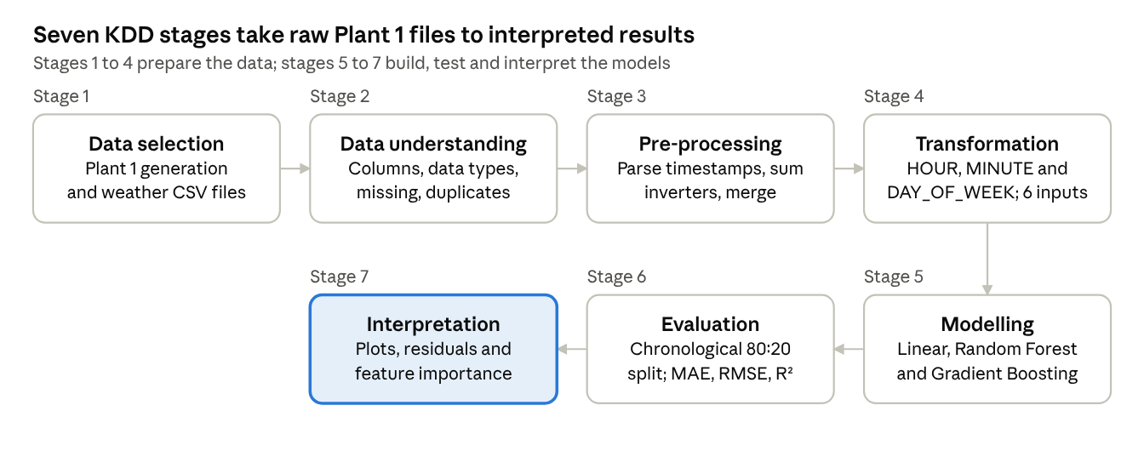
KDD workflow · 7 stages
Figure 3.1: KDD workflow followed in this project, from data selection to interpretation of results. Stages 1 to 4 prepare the data (top row, left to right); stages 5 to 7 continue along the bottom row, right to left.

3.2 Data Selection and Description
Source. The data are the Indian Solar Power Generation Data published on Kaggle (Kannal, n.d.). According to the dataset description, the data were gathered at two solar power plants in India over a 34-day period. Each plant has one generation file, recorded at inverter level, and one weather-sensor file, recorded at plant level. The notebook downloads the dataset automatically with the kagglehub library, so no manual download is needed.
Scope. Only Plant 1 is used, through two files: Plant_1_Generation_Data.csv and Plant_1_Weather_Sensor_Data.csv. The generation file contains 68,778 rows and 7 columns. The weather file contains 3,182 rows and 6 columns. Both files report the single plant identifier 4135001. After parsing, both span the period from 15 May 2020 00:00 to 17 June 2020 23:45, with readings at 15-minute intervals.
Table 3.1: Columns of the Plant 1 files and their role in this project
Column | File | Type as loaded | Meaning | Role in this project
DATE_TIME | Both | object (text) | Timestamp of the reading | Parsed to datetime; source of HOUR, MINUTE and DAY_OF_WEEK
PLANT_ID | Both | int64 | Plant identifier | Grouping and merge key
SOURCE_KEY | Both | object | Identifier of the reporting device (inverter in the generation file) | Not used as an input
DC_POWER | Generation | float64 | DC power reading | Excluded from inputs
AC_POWER | Generation | float64 | AC power reading per inverter | Summed to plant level; target variable
DAILY_YIELD | Generation | float64 | Daily yield reading | Excluded from inputs
TOTAL_YIELD | Generation | float64 | Total (cumulative) yield reading | Excluded from inputs
AMBIENT_TEMPERATURE | Weather | float64 | Ambient temperature | Input feature
MODULE_TEMPERATURE | Weather | float64 | PV module temperature | Input feature
IRRADIATION | Weather | float64 | Solar irradiation | Input feature
The notebook does not state the units of the weather columns, so none are assumed in this report.

3.3 Data Understanding
The notebook inspected the column names, data types, missing values and duplicate rows of both files. Findings: there are no missing values in any column of either file, and there are no duplicate rows in either file. The first rows show that generation timestamps are written in day-month-year form (for example 15-05-2020 00:00), whereas weather timestamps are written in year-month-day form (2020-05-15 00:00:00). Both columns were loaded as text and had to be parsed into datetimes.
After pre-processing (Section 3.4), descriptive statistics were computed on the 3,157 merged observations.
Table 3.2: Descriptive statistics of the target and weather variables (n = 3,157)
Variable | Mean | Std. dev. | Min | 25% | Median | 75% | Max
AC_POWER (kW) | 6704.830534 | 8604.217954 | 0.000000 | 0.000000 | 814.880357 | 13752.112500 | 29150.212499
AMBIENT_TEMPERATURE | 25.560257 | 3.351059 | 20.398505 | 22.739895 | 24.680324 | 27.941221 | 35.252486
MODULE_TEMPERATURE | 31.175453 | 12.272685 | 18.140415 | 21.130249 | 24.801971 | 41.449481 | 65.545714
IRRADIATION | 0.230103 | 0.301348 | 0.000000 | 0.000000 | 0.027748 | 0.451576 | 1.221652
Interpretation. The 25th percentile of both AC_POWER and IRRADIATION is zero, which shows that a large share of the observations were recorded when the plant was not generating, as expected for night-time. The target therefore has a very skewed distribution.
The notebook also plotted the target distribution and the relationship between AC_POWER and each weather variable (Figure 3.2).
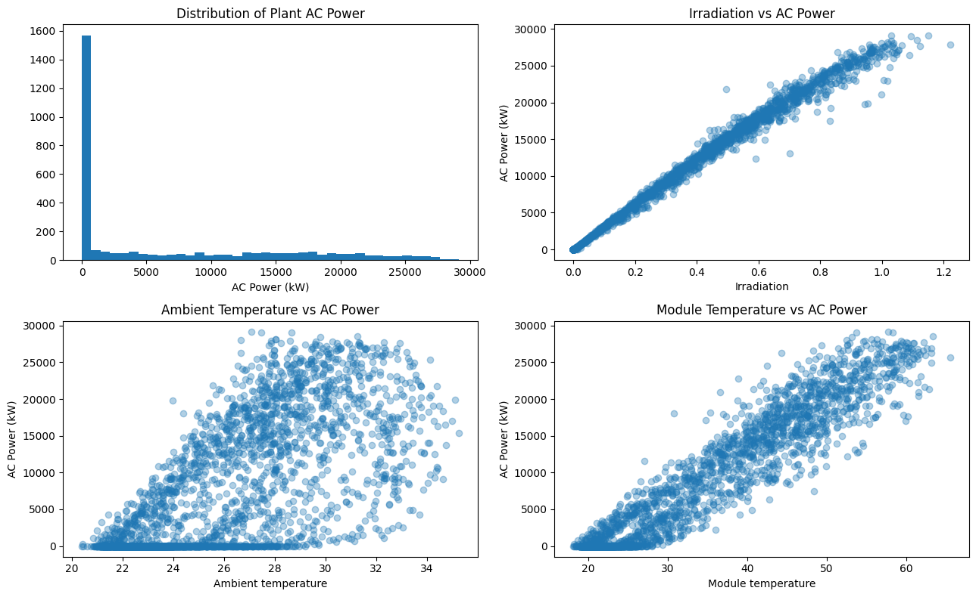
Figure 3.2: Distribution of plant AC power and scatter plots of AC power against irradiation, ambient temperature and module temperature (output of the executed notebook)
Interpretation. The histogram shows a large spike at zero, with the remaining observations spread over a wide range up to about 30,000 kW. The scatter of AC_POWER against IRRADIATION is a narrow, almost linear band. The plots against ambient and module temperature are more widely scattered. These are visual observations; they show association, not causation.

3.4 Pre-processing
The notebook carried out the following steps in order.
- Column validation. The notebook checked that the required columns were present in both files and stopped with an error if they were not.
- Duplicate removal. Duplicate rows were dropped. As reported in Section 3.3, none were found.
- Timestamp parsing. DATE_TIME was converted to a datetime type in both files. AC_POWER and the three weather columns were converted to numeric types. Rows with a missing DATE_TIME, PLANT_ID or AC_POWER (generation) and a missing DATE_TIME or PLANT_ID (weather) would have been dropped. The printed timestamp ranges of the two files are identical.
- Aggregation of inverter readings. The generation file has one row per inverter per timestamp. Plant-level output was obtained by summing AC_POWER over all inverters at each timestamp (Equation 3.1).
- Weather grouping. Weather readings were averaged per plant and timestamp. The grouped table has the same number of rows as the original weather file, which indicates that there was one reading per timestamp.
- Merging. The plant-level generation table and the weather table were joined on PLANT_ID and DATE_TIME with an inner join, validated as one-to-one, and sorted by time.
P_t = \sum_{i \in I_t} \mathrm{AC\_POWER}_{i,t}
Equation 3.1: Plant-level AC power at timestamp t, where I_t is the set of inverters reporting at that timestamp.
Table 3.3: Number of rows and columns through the pre-processing steps
Stage | Rows × columns | Contents
Generation file as loaded | 68,778 × 7 | Inverter-level readings
Weather file as loaded | 3,182 × 6 | Plant-level sensor readings
Plant-level generation | 3,158 × 3 | PLANT_ID, DATE_TIME, AC_POWER
Timestamp-level weather | 3,182 × 5 | PLANT_ID, DATE_TIME and three weather columns
Merged dataset | 3,157 × 6 | Plant-level AC_POWER with weather; no missing values
Interpretation. The merged dataset has one row fewer than the plant-level generation table. Because the join keeps only matching timestamps, this implies that one generation timestamp had no weather record. The notebook does not display which timestamp it was. The notebook also does not check how many inverters reported at each timestamp, so a timestamp with a missing inverter reading would give a lower sum. This is noted as a limitation in Chapter 5.

3.5 Feature Engineering and Leakage Prevention
Time features. Three features were derived from DATE_TIME: HOUR (0–23), MINUTE and DAY_OF_WEEK (numbered from 0, with Monday as 0). Together with the three weather columns, they form the six input features in Table 3.4.
Table 3.4: Target variable and input features
Variable | Type | Origin
AC_POWER (kW) | Target | Sum of inverter AC power per timestamp
IRRADIATION | Input | Weather sensor
AMBIENT_TEMPERATURE | Input | Weather sensor
MODULE_TEMPERATURE | Input | Weather sensor
HOUR | Input | Derived from DATE_TIME
MINUTE | Input | Derived from DATE_TIME
DAY_OF_WEEK | Input | Derived from DATE_TIME
Leakage prevention. Following the definition of Kaufman et al. (2012), leakage means giving a model information about the target that it should not legitimately have. The notebook therefore excluded DC_POWER, DAILY_YIELD, TOTAL_YIELD and SOURCE_KEY from the inputs. The reasoning, which is an interpretation rather than a notebook output, is as follows. DC_POWER, DAILY_YIELD and TOTAL_YIELD are other generation readings recorded alongside the target, so they could carry the answer directly or indirectly. SOURCE_KEY identifies individual inverters, which no longer exist as separate units once output is aggregated to plant level.
Two further safeguards were built into the design. First, the median imputation and scaling steps are placed inside scikit-learn pipelines, so they are fitted on the training data only. Second, the evaluation uses a chronological split (Section 3.7). The measured weather at the same timestamp is a legitimate input for estimation, but it would not be available in advance for forecasting, which is why this study does not claim forecasting ability.

3.6 Predictive Models
Three regression algorithms were compared, all implemented with scikit-learn (Pedregosa et al., 2011). Each was wrapped in a pipeline that begins with median imputation. The notebook used a fixed random state of 42 for reproducibility. No hyperparameter tuning is shown in the notebook, and parameters that are not listed in Table 3.5 were left at their scikit-learn default values.
Table 3.5: Models and settings used in the notebook
Model | Pipeline | Settings
Linear Regression | Median imputer, StandardScaler, LinearRegression | Default
Random Forest Regressor | Median imputer, RandomForestRegressor | 200 trees; min_samples_leaf = 2; random_state = 42; n_jobs = -1
Gradient Boosting Regressor | Median imputer, GradientBoostingRegressor | 150 estimators; learning_rate = 0.05; max_depth = 3; random_state = 42
Linear Regression models the target as a weighted sum of the inputs plus an intercept (Equation 3.2). It was selected as a simple, interpretable baseline. If the tree-based models cannot outperform it, their added complexity is not justified. Features were standardised before fitting.
\hat{y} = \beta_0 + \sum_{j=1}^{6} \beta_j x_j
Equation 3.2: Linear Regression, with six input features x_j and fitted coefficients β_j.
Random Forest Regressor (Breiman, 2001) builds many decision trees on bootstrap samples of the training data and averages their predictions (Equation 3.3). It was selected because it can capture non-linear relationships and interactions without feature scaling, and averaging many trees reduces the variance of a single tree.
\hat{y} = \frac{1}{B} \sum_{b=1}^{B} T_b(x)
Equation 3.3: Random Forest prediction as the average of B tree predictions T_b(x); here B = 200.
Gradient Boosting Regressor (Friedman, 2001) builds trees one after another, with each new tree fitted to correct the errors of the current ensemble. The prediction is updated in small steps controlled by the learning rate (Equation 3.4). It was selected as a strong and widely used method for tabular data that complements bagging-based Random Forest. For general background on these methods, see Hastie et al. (2009).
F_m(x) = F_{m-1}(x) + \nu \, h_m(x)
Equation 3.4: Gradient Boosting update, where h_m is the m-th tree and ν is the learning rate (0.05 here); the notebook used 150 boosting stages.

3.7 Chronological 80:20 Train/Test Split
The merged data were already sorted by time. The first 80% of rows formed the training set and the last 20% formed the test set, with no shuffling. The split index was computed as the integer part of 0.8 × 3,157, which is 2,525.
Table 3.6: Training and test sets
Set | Rows | Period
Training | 2,525 | 15 May 2020 00:00 to 11 June 2020 09:15
Testing | 632 | 11 June 2020 09:30 to 17 June 2020 23:45
The reason for a chronological split is that neighbouring 15-minute observations are strongly related. If the rows were shuffled randomly, test observations would have training observations immediately before and after them, which would probably make the evaluation look better than it should. A chronological split keeps the test period entirely later than the training period. Two consequences should be noted. The test period covers about 6.6 days, and because the split falls at 09:30 on 11 June, the test set begins part-way through a day.

3.8 Evaluation Metrics
Let y_i be the actual AC power of the i-th test observation, ŷ_i the predicted value, ȳ the mean of the actual values, and n the number of test observations (here 632). Three metrics were used.
\mathrm{MAE} = \frac{1}{n} \sum_{i=1}^{n} \left| y_i - \hat{y}_i \right|
Equation 3.5: Mean Absolute Error, the average size of the error in kW. Lower is better.
\mathrm{RMSE} = \sqrt{\frac{1}{n} \sum_{i=1}^{n} \left( y_i - \hat{y}_i \right)^2}
Equation 3.6: Root Mean Squared Error, in kW. Squaring gives larger errors more weight, so RMSE is more sensitive to occasional large errors than MAE. Lower is better.
R^2 = 1 - \frac{\sum_{i=1}^{n} \left( y_i - \hat{y}_i \right)^2}{\sum_{i=1}^{n} \left( y_i - \bar{y} \right)^2}
Equation 3.7: Coefficient of determination, the share of the variance of the actual values that the model explains. A value closer to 1 is better.
A residual is defined as actual minus predicted (y_i − ŷ_i), as in the notebook. The best model was defined as the one with the lowest test RMSE. Reporting several metrics follows the recommendation of Chai and Draxler (2014) that a combination of metrics gives a fuller picture than a single one.

3.9 Implementation Environment
The project was implemented in Python in a Google Colab notebook, using Pandas and NumPy for data handling, Matplotlib for plots, scikit-learn for pipelines, models and metrics, and kagglehub for dataset download. All models were evaluated on the same test set, and the notebook uses a fixed random state (42) so that the results can be reproduced.

Chapter 4: Results and Discussion
All numerical results in this chapter are taken from the executed notebook. Values the notebook printed are reported as printed (to four decimal places for the model metrics). Statements marked Interpretation are the author's reading of those results and are not notebook outputs. A small number of simple ratios were computed from the printed values and are identified as such.

4.1 Model Comparison
All three models were evaluated on the same 632 test observations (11 June 2020 09:30 to 17 June 2020 23:45). The notebook sorted the results by test RMSE and selected the best model on that basis.
Table 4.1: Test-set performance of the three models (sorted by RMSE)
Rank by RMSE | Model | MAE (kW) | RMSE (kW) | R²
1 | Gradient Boosting | 244.8238 | 480.0973 | 0.9964
2 | Random Forest | 238.9281 | 490.4442 | 0.9962
3 | Linear Regression | 502.6576 | 806.3010 | 0.9898
Result. The notebook reports Gradient Boosting as the best model by test RMSE (480.0973 kW). Random Forest has the lowest MAE (238.9281 kW), and Linear Regression has the highest MAE and RMSE of the three. Figure 4.1 reproduces the notebook's own comparison charts.
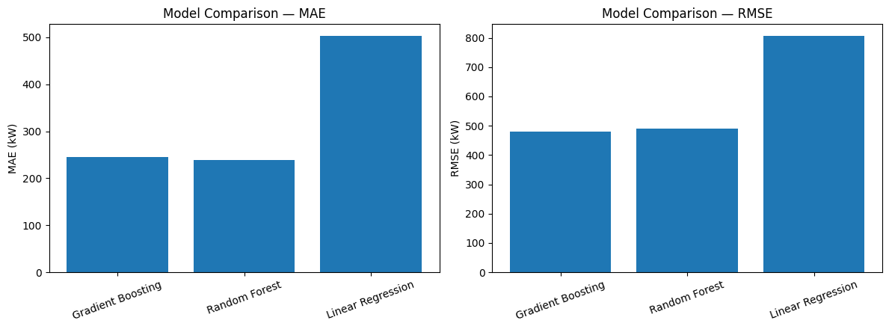
Figure 4.1: Model comparison by MAE (left) and RMSE (right), as produced by the executed notebook.
Computed comparisons. From the values in Table 4.1, Gradient Boosting's RMSE is 10.3469 kW lower than Random Forest's (about 2.1%), while Random Forest's MAE is 5.8957 kW lower than Gradient Boosting's. Linear Regression's MAE is about 2.05 times that of Gradient Boosting, and its RMSE is about 1.68 times as large.
Interpretation.
- The two tree-based ensembles perform very similarly, and both clearly outperform the linear baseline. The ordering of Gradient Boosting and Random Forest depends on which metric is used: Random Forest is slightly better on MAE and Gradient Boosting slightly better on RMSE and R².
- The notebook evaluates a single run on a single test period and does not include repeated runs, cross-validation or significance tests. The difference between the two ensembles is small, so the ranking between them should be treated as tentative.
- For all three models, RMSE is well above MAE (about 1.96 times for Gradient Boosting, 2.05 for Random Forest and 1.60 for Linear Regression, computed from Table 4.1). Because RMSE penalises large errors more heavily, this suggests that most errors are small but a minority are much larger. The residual plots in Section 4.3 are consistent with this.
- Linear Regression still reaches R² = 0.9898, which indicates that a large part of the variation in AC_POWER can be explained by an approximately linear relationship with the inputs, in line with the near-linear scatter of AC_POWER against IRRADIATION in Figure 3.2.
- For scale, the mean AC_POWER over all 3,157 observations is 6704.830534 kW (Table 3.2), and Gradient Boosting's MAE is about 3.7% of that value. The test-set mean was not reported, so this is only a rough indication.

4.2 Actual versus Predicted Values
Figure 4.2 plots the actual test-set AC power against the Gradient Boosting predictions, with a dashed 1:1 reference line.
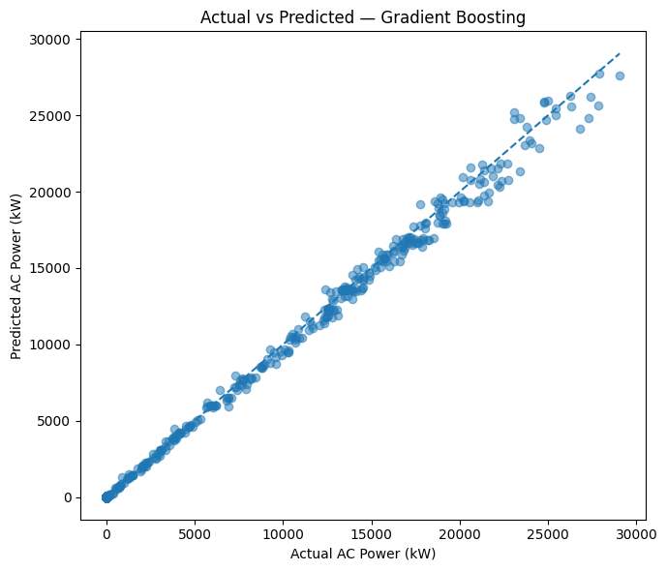
Figure 4.2: Actual versus predicted AC power on the test set for Gradient Boosting (output of the executed notebook).
Observation. The points lie close to the dashed line across the whole range, from zero up to about 29,000 kW. A few points at the highest power levels fall visibly below the line, which means the model predicted less than the actual value there.
Interpretation. The close agreement is consistent with the high R² (0.9964) in Table 4.1. Because the target contains many zero values (Table 3.2), part of this agreement comes from the model correctly predicting zero output when there is no sunlight. The notebook does not report errors separately for daytime and night-time, so the accuracy during generating hours alone cannot be stated from the available outputs.

4.3 Residual Analysis
Residuals were computed as actual minus predicted values for the Gradient Boosting model (Figure 4.3). The left panel plots residuals against predicted power, and the right panel shows their distribution.
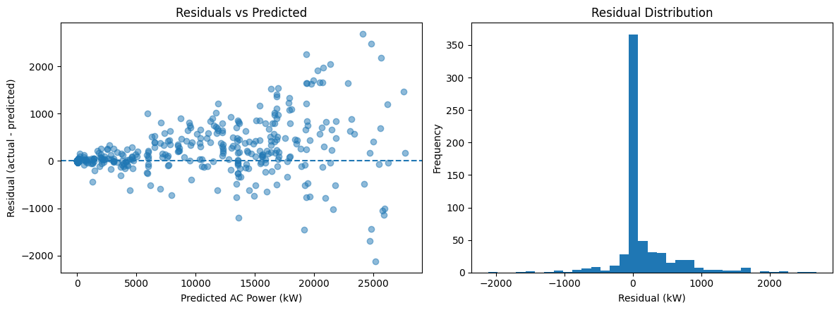
Figure 4.3: Residuals versus predicted AC power (left) and distribution of residuals (right) for Gradient Boosting (output of the executed notebook).
Observations.
- Residuals are tightly grouped around zero when predicted power is low, and their spread becomes wider as predicted power increases.
- Residuals of both signs occur at high predicted power. Read from the plot, they range roughly from about −2,000 kW to about +2,700 kW.
- The histogram is sharply peaked at zero, with relatively few observations in the tails on either side.
Interpretation. Errors are small for most observations and larger when the plant produces a lot of power, which is a pattern in which the absolute error grows with the output level. This agrees with RMSE being much larger than MAE. A likely contributor, which the notebook does not test, is that the many zero-output observations are predicted almost exactly and so create the tall peak at zero. Possible reasons for the larger high-power errors, such as short-term cloud variability or inverter behaviour, are not examined in the notebook and cannot be confirmed from its outputs.

4.4 Feature Importance
The notebook extracted the importance values from the tree-based model with the lower RMSE, which is Gradient Boosting. These are the impurity-based importances provided by scikit-learn, and they sum to 1.
Table 4.2: Feature importance for Gradient Boosting
Rank | Feature | Importance
1 | IRRADIATION | 0.998540
2 | HOUR | 0.000511
3 | MODULE_TEMPERATURE | 0.000425
4 | AMBIENT_TEMPERATURE | 0.000346
5 | DAY_OF_WEEK | 0.000166
6 | MINUTE | 0.000012
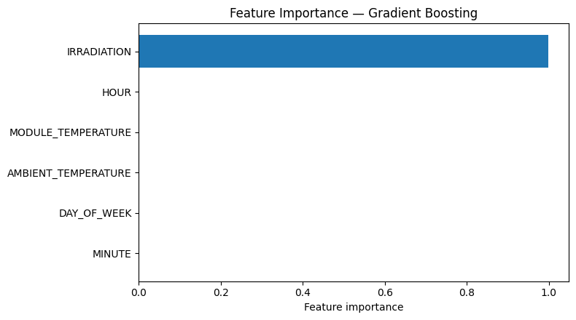
Figure 4.4: Feature importance for Gradient Boosting (output of the executed notebook).
Result. IRRADIATION accounts for 0.998540 of the total importance. The five other features together account for 0.001460.
Interpretation.
- The dominance of irradiation agrees with the physical expectation that sunlight is the energy input to a PV plant (Section 2.3) and with the near-linear scatter in Figure 3.2.
- The small importance of the temperature variables does not prove that temperature has no effect on PV output. Module and ambient temperature are likely to move together with irradiation during the day, so much of the information they carry may already be captured by irradiation. The notebook did not compute correlations or run an experiment that removes features, so this explanation is a hypothesis only.
- The small importance of HOUR, MINUTE and DAY_OF_WEEK should not be over-interpreted. With about 34 days of data, any weekly pattern cannot be estimated reliably.
- As the notebook itself notes, feature importance indicates predictive usefulness, not causation.

4.5 Practical Meaning of the Results
Within this dataset, measured irradiation together with simple weather and time features is enough to estimate Plant 1's AC power with a test RMSE of 480.0973 kW. For scale, this is about 1.6% of the maximum AC power observed in the data (29,150.212499 kW; Table 3.2), computed from the printed values. The practical message is that a simple model driven mainly by measured irradiation reproduces the plant's output pattern well when the weather is known at the same moment.
Two cautions apply to any practical reading. First, the model needs measured weather at the same timestamp, so it cannot predict the output of tomorrow or of the next hour from the information used here. Second, the results come from one plant over about 34 days in May and June 2020, so they should not be taken to show how the model would behave in other seasons, at other plants, or over a full year. The results should not be used to claim suitability for year-round forecasting.
The notebook ends with a cell that computes an illustrative prediction from example inputs. The output of that cell is not shown in the executed PDF, so no value from it is reported in this report.

4.6 Strengths and Weaknesses of the Study
Table 4.3: Strengths and weaknesses of the approach
Aspect | Strength | Weakness
Data | Public dataset with no missing values or duplicates; plant-level target built explicitly from inverter data | One plant and about 34 days; no other seasons or sites
Features | Closely related generation columns excluded to limit leakage | Number of reporting inverters per timestamp was not checked before summing
Evaluation | Chronological split; three complementary metrics; all models scored on the same test set | Single run and single test period of about 6.6 days; no cross-validation or confidence intervals; training-set metrics not reported, so over-fitting cannot be assessed
Models | Simple baseline compared against two tree ensembles | No hyperparameter tuning shown; only three algorithms
Interpretation | Actual-versus-predicted, residual and importance analyses all consistent with each other | Impurity-based importance only; no daytime-only error analysis
Use case | Clear and honest framing as same-timestamp estimation | Requires measured weather at the time of estimation, so it is not a forecasting model

